Important Note: index.html was made as a MVP for the hackathon under limited time. It only works on the local host (using ganache-cli) and requires manual input to certain components.

1. Launch ganache-cli
2. Open <http://remix.ethereum.org>
   1. On the top right “run” tab, set environment to “Web3 provider”
   2. Connect to <http://localhost:8545>
3. Add your solidity .sol file to browser
4. In the Settings tab, select the appropriate Solidity version
5. Compile the .sol file
6. Then select the desired token, press detail
   1. Copy the ABI value to clipboard
   2. In the index.html, paste it inside var pixelContract = web3.eth.contract(PASTE_ABI_VALUE_HERE)
7. Back to remix, in “run” tab, select desired Token and deploy
8. Copy the address under “Deployed Contract”

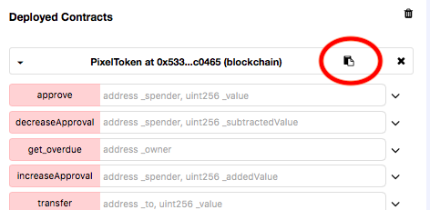

9) Paste the address to “index.html” under var addr = (‘ADDRESS_HERE’)

10) Open the index.html in browser and enjoy!

Notes:

ABI value looks like this:

[

{

"constant": true,

"inputs": [],

"name": "name",

"outputs": [

{

"name": "",

"type": "string"

}

],

"payable": false,

"stateMutability": "view",

"type": "function"

}, ………etc…….

Note2: initial token supplied to coinbase (the default account is 1000 pixel tokens), therefore can’t give the other accounts >1000 Pixel Tokens (unless another function is written to do mint creation)